Q1

TITLE My First Program (Test.asm)

INCLUDE Irvine32.inc

.code

main PROC

mov eax,0

add eax,47

add eax,39

add eax,60

add eax,85

add eax,64

add eax,54o

sub eax,0Ah

call Dumpregs

exit

main ENDP

END main

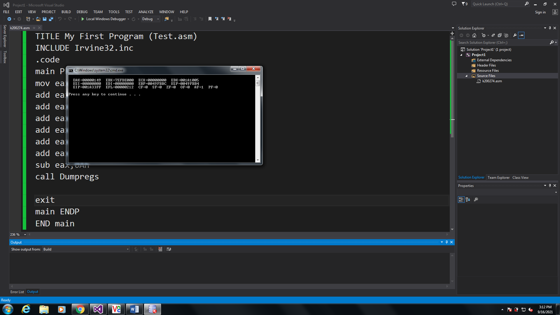

Q2

TITLE My First Program (Test.asm)

INCLUDE Irvine32.inc

.code

main PROC

mov eax,0

add eax,30

sub eax,9

add eax,186

sub eax,150

call Dumpregs

exit

main ENDP

END main

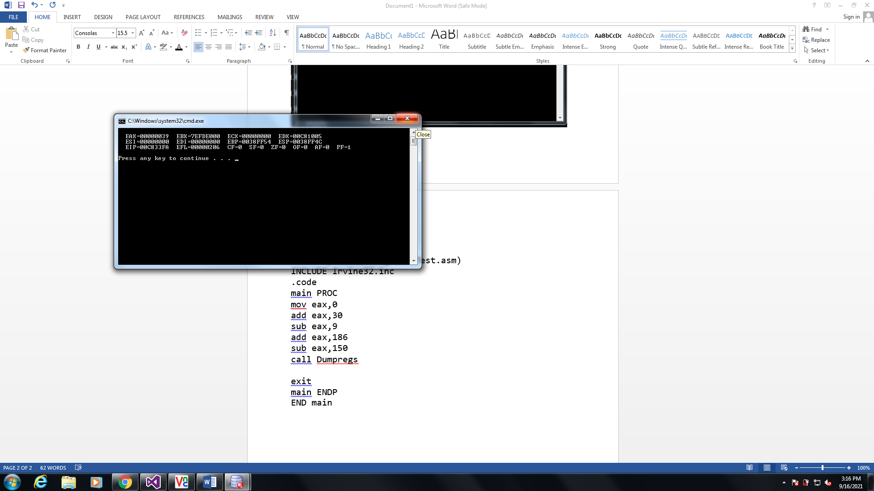

Q3

TITLE My First Program (Test.asm)

INCLUDE Irvine32.inc

.code

main PROC

mov eax,0

add eax,101110b

add eax,50Ah

add eax,6710d

add eax,1010001b

add eax,0Fh

call Dumpregs

exit

main ENDP

END main

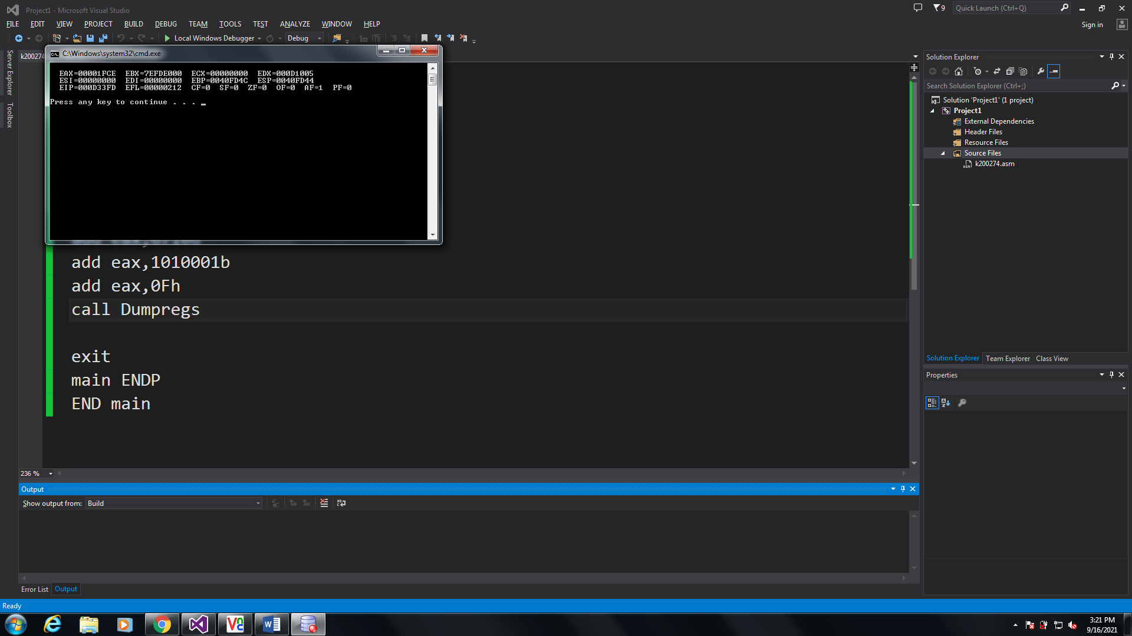

Q4

TITLE My First Program (Test.asm)

INCLUDE Irvine32.inc

.code

main PROC

mov eax,0

add eax,10001101b;

sub eax,0D83h

add eax,385

add eax,10

add eax,1111101b

sub eax,0Eh

add eax,0Fh

call Dumpregs

exit

main ENDP

END main

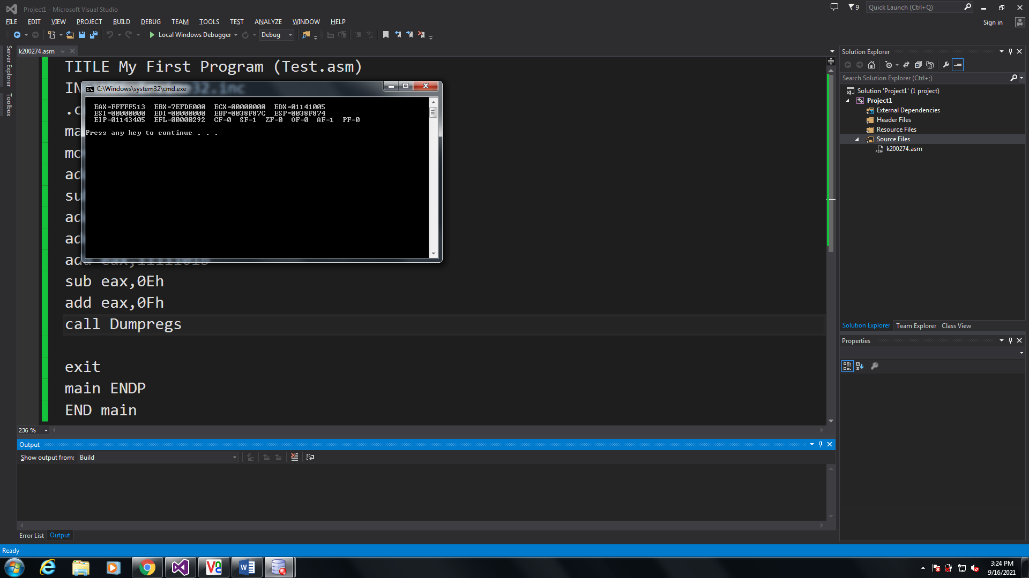

Q5

INCLUDE Irvine32.inc

.code

main PROC

;intializing registers

mov edx,0

mov eax,1

mov ecx,2

mov edx,3

add edx,1

add edx,ebx

add edx,edx

sub edx,ecx

add edx,0Ah

add edx,65o

add edx,73d

sub edx,eax

call DumpRegs

exit

main ENDP

END main

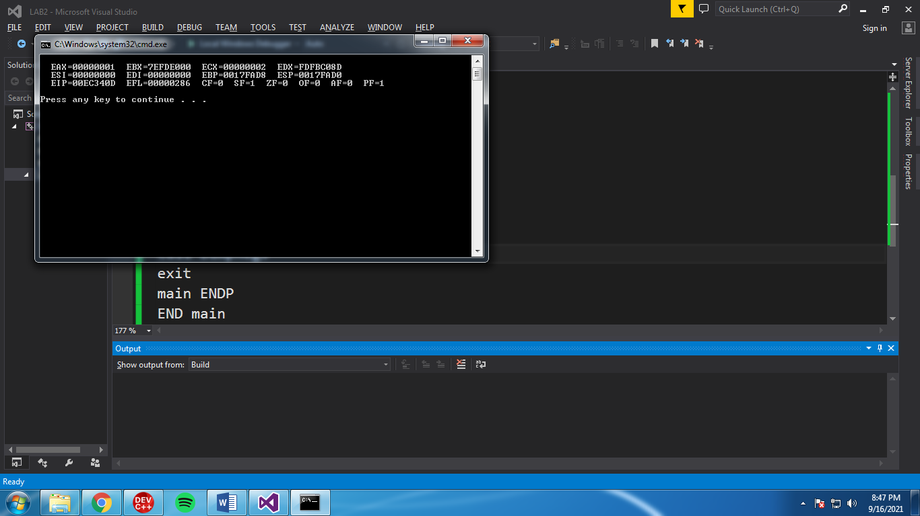

Q6

INCLUDE Irvine32.inc

.code

main PROC

;intializing registers

mov eax,0

add eax,5ADh

sub eax,eax

add eax,65o

add eax,65d

add eax,11110111b

add eax,150

sub edx,eax

call DumpRegs

exit

main ENDP

END main

